BRICK BY BRICK 1 – UNIT 3
EXTRA ACTIVITY

1. CIRCLE THE MATCHING NUMBER OF ITEMS.

5

3

2
4
Images by Pixabay.

2. READ, TRACE, AND DRAW.

TEACHER

STUDENT

BOARD

3. READ AND COLOR.
Images by Pixabay.
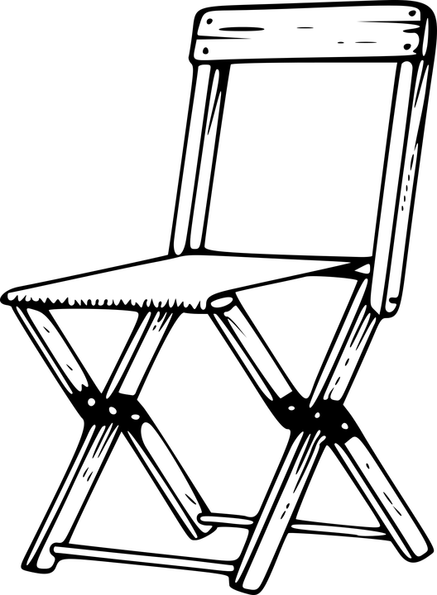 | 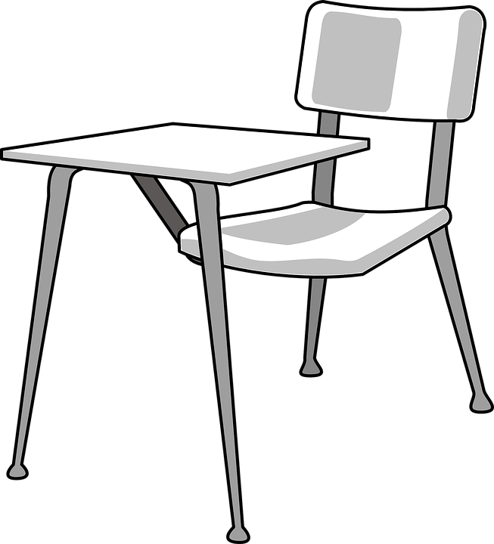
A RED CHAIR | A BROWN DESK
4. READ AND CHECK ( ✔ ).
 | 
1) TEACHER  ☐ YES NO | 2) STUDENT  ☐ YES ☐ NO
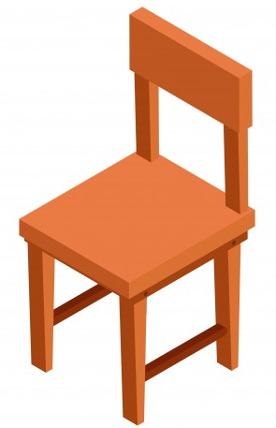 |   Images by Freepik & Pixabay.
3) CHAIR  ☐ YES ☐ NO | 4) MARKER  ☐ YES ☐ NO

5. LOOK AT THE PICTURE AND CIRCLE.

TEACHER / STUDENTS / BOARD

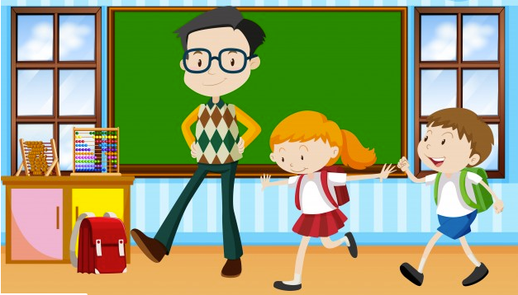
Images by Freepik.

